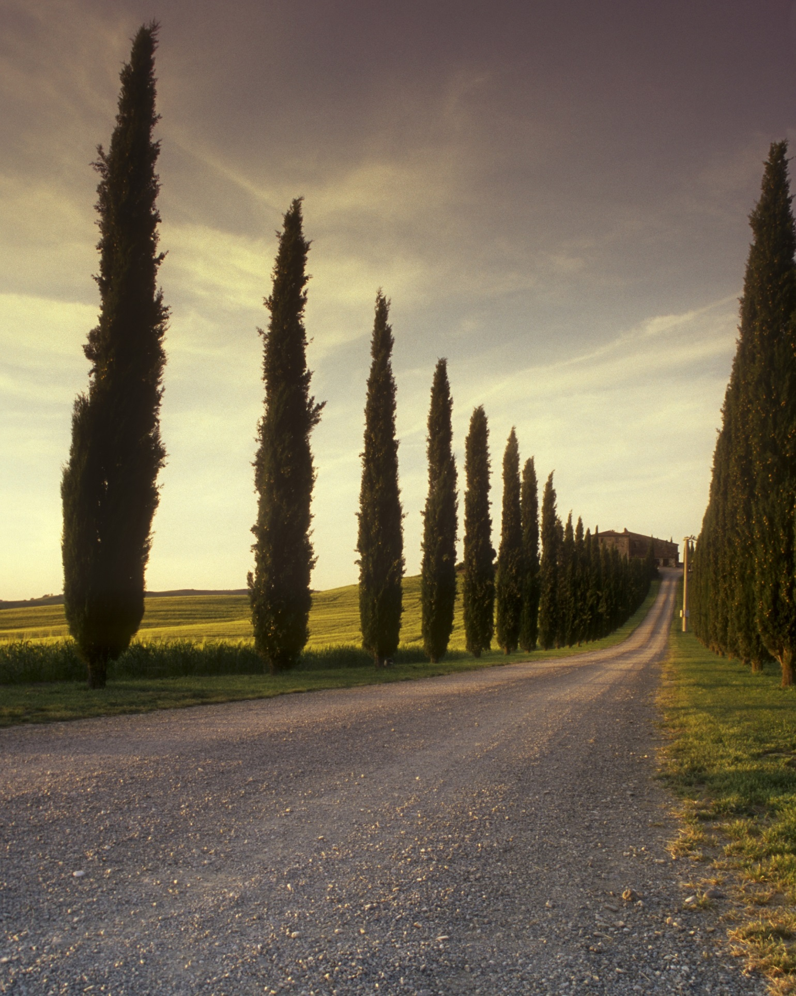  MPHAPHULI & PARTNERS | ANTENDAHO MPHAPHULI  2025

Contents
- DESCRIPTION:
- WHY WE STARTED:
- MISSION STATEMENT
- VISION STATEMENT
- WEBSITE SERVICES:
- WEBSITE STRUCTURE:
- TOOLS USED:
- PROJECT ASSETS:
- PROJECT TIME FRAME:
- References

DESCRIPTION:
MPHAPHULI & PARTNERS is a non-profit organization that aims to provide a comprehensive support system for street individuals struggling with addiction, empowering them to overcome their dependencies, reintegrate into society, and lead healthy, fulfilling lives.

WHY WE STARTED:
We started with the aim to provide a second chance at life and dignity for homeless individuals struggling with addiction. Many homeless people struggling with addiction feel hopeless, forgotten and marginalized. They deserve a second chance to break free from the cycle of addiction, regain their dignity, and rebuild their lives.

MISSION STATEMENT
Our mission is to help homeless people with their addiction problems and mainly to help them get off the streets by taking them to rehabilitation centres until they get the help that they need, which is a step to getting back on their feet.

VISION STATEMENT
Reclaiming lives, restoring hope and guiding homeless individuals from streets to stability through rehabilitation.

WEBSITE SERVICES:
Insight of web:
The information was sourced from NGOPLUSE (ngopluse.net). The information is to make people aware of the journey we have embarked on, so that people who have the calling of helping others can take part in helping us achieve our goal of helping homeless people from the street.
Images:
The images used are license-free and sourced from platforms like Freepik and Vecteezy to ensure copyright compliance. The images show homeless people with drug addiction.
Logo:
A simple and recognizable logo was designed for MPHAPHULI & PARTNERS to represent the organization.
Graphics:
Graphics were created to increase the visual appeal of the website.

1.Home Page (index.html):
Introduction to MPHAPHULI & PARTNERS highlighting the organization’s mission and goal.

2.About_Us Page (about_Us.html):
Detailed information about MPHAPHULI & PARTNER’S mission and goals.
It includes a section on the organization’s history, team members and communication impact

3.Services Page(service.html):
The services offered by MPHAPHULI & PARTNERS include helping homeless people, by providing them with shelter, food and many more other basics one would need to live.

4.Contact Page(contact.html):
The contact page for MPHAPHULI & PARTNERS includes phone numbers, email and physical address.
Includes social media page and subscribing to the newsletter.

WEBSITE STRUCTURE:
Page | File Name | Description
Home Page | index.html | Introduction to MPHAPHULI & PARTNERS highlighting the organisation’s mission and goal.
About Us | about_us.html | Detailed information about MPHAPHULI & PARTNER’S mission, goals, history, team, and impact.
Services | service.html | Details on services like shelter, food, rehabilitation, and basic needs.
Contact | contact.html | Contact information, social media, and newsletter subscription.

TOOLS USED:
Tool Type | Tool Name | Purpose
Frontend Development | HTML, CSS, JavaScript | Structure, styling, interactivity
Design | Canva / Adobe Illustrator | Logo, graphics
Image Resources | Freepik, Vecteezy | License-free images
Version Control (Optional) | Git, GitHub | Code versioning and collaboration
Text Editor | Visual Studio Code / Sublime Text | Writing and editing code
Browser Developer Tools | Chrome / Firefox DevTools | Debugging and layout inspection

PROJECT ASSETS:
Asset Type | Source | Notes
Images | Freepik, Vecteezy | Homelessness, rehabilitation, recovery images
Logo | Custom-designed | Simple, recognizable, non-profit identity
Graphics | Custom or open source | Enhance visual appeal, storytelling
Fonts | Google Fonts or system fonts | Clean and readable typography
Color Palette | Earth tones, calming colors | Representing hope, care, and stability

PROJECT TIME FRAME:
Phase | Task | Duration
Week 1 | Planning & Research | 2–3 days
Week 1 | Gather content and assets | 2 days
Week 2 | Design logo and graphics | 2 days
Week 2 | Create HTML structure for all pages | 3 days
Week 3 | Style website using CSS | 3–4 days
Week 3 | Insert images, text content | 2 days
Week 4 | Add interactivity with JavaScript | 2 days
Week 4 | Test website responsiveness and functionality | 2 days
Week 4 | Final review and adjustments | 1–2 days

References
Anon., n.d. [Online] Available at: https://vecteezy.com [Accessed May 2007].
Anon., n.d. Freepik. [Online] Available at: https://freepik.com [Accessed 23 March 2025].
Anon., n.d. Organisation for treatment and rehabilitation purposes. s.l.:s.n.

